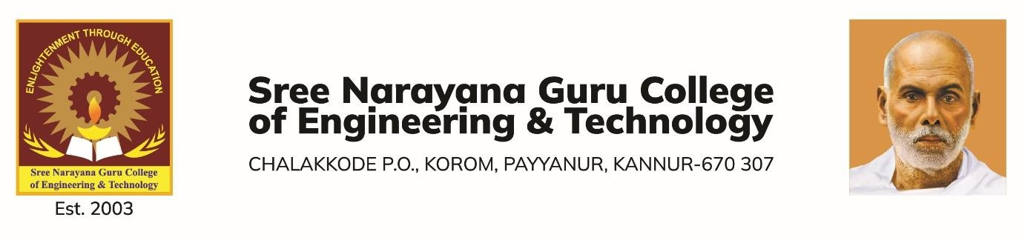

DEPARTMENT OF COMPUTER SCIENCE AND ENGINEERING

REPORT - EXPERT TALK AND WORKSHOP ON MACHINE LEARNING

The Department of Computer Science and Engineering organized an expert talk and workshop on **18th July 2025 at 9:30 AM** in **Mahakavi Kumaranashan Hall**, attended by **S7 CSE students**. The objective was to introduce the fundamentals of **machine learning** and offer hands-on experience through the implementation of a simple ML project. The event began with a welcome address by **Ms. Sharija P., Assistant Professor, CSE**, and event coordinator, who expressed gratitude to the participants and faculty for their active engagement and support.

The session began with a lecture by Mr. Sreeraj S., introducing the participants to machine learning. He covered supervised, unsupervised, and semi-supervised learning, popular ML algorithms, real-world applications, and the challenges and future scope of ML. The talk also highlighted ethical considerations and best practices in model development and deployment.

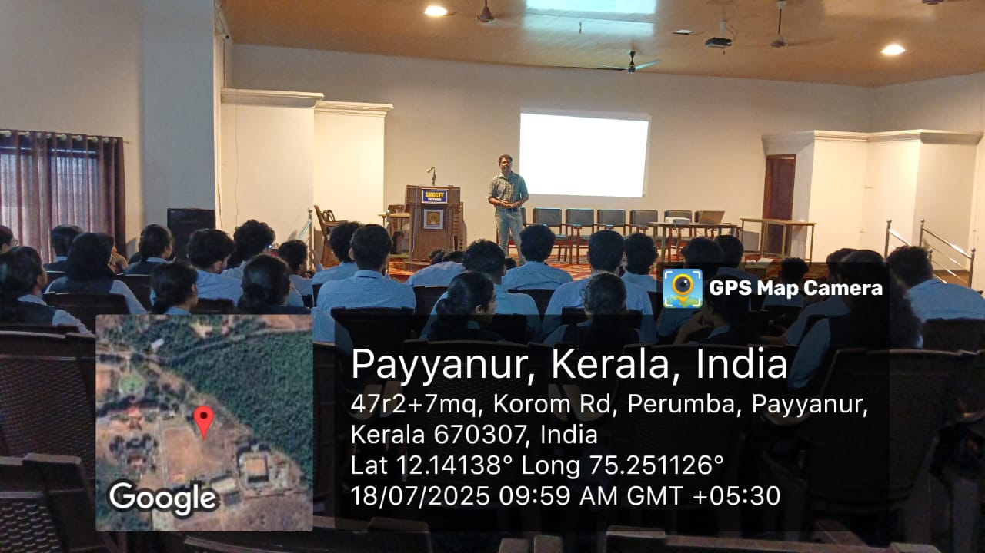

The hands-on session was conducted from 1.00 PM to 4.00 PM at the Networking Lab, where students had the opportunity to implement a simple machine learning project under the guidance of the resource person. Students worked individually and completed the full pipeline of an ML model. The students found the workshop useful in bridging the gap between theory and practical applications. Feedback collected from students and resource person was overwhelmingly positive, indicating strong engagement and interest.

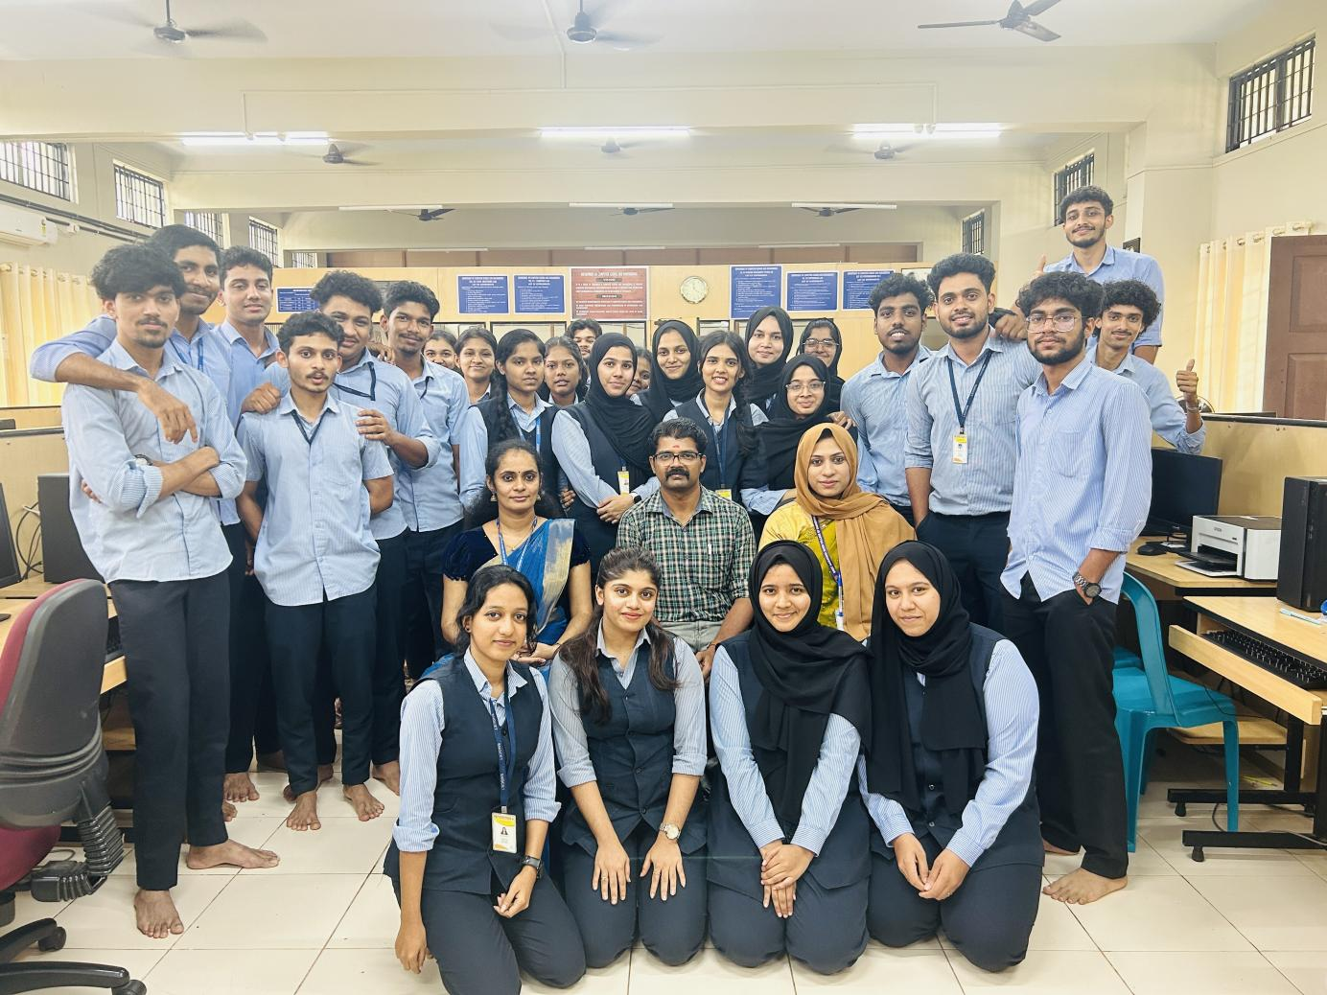

The expert talk and hands-on workshop provided a valuable and enriching learning experience for all participants. The practical session, in particular, allowed students to apply their theoretical knowledge, fostering deeper engagement and sparking a continued interest in the field of Machine Learning.